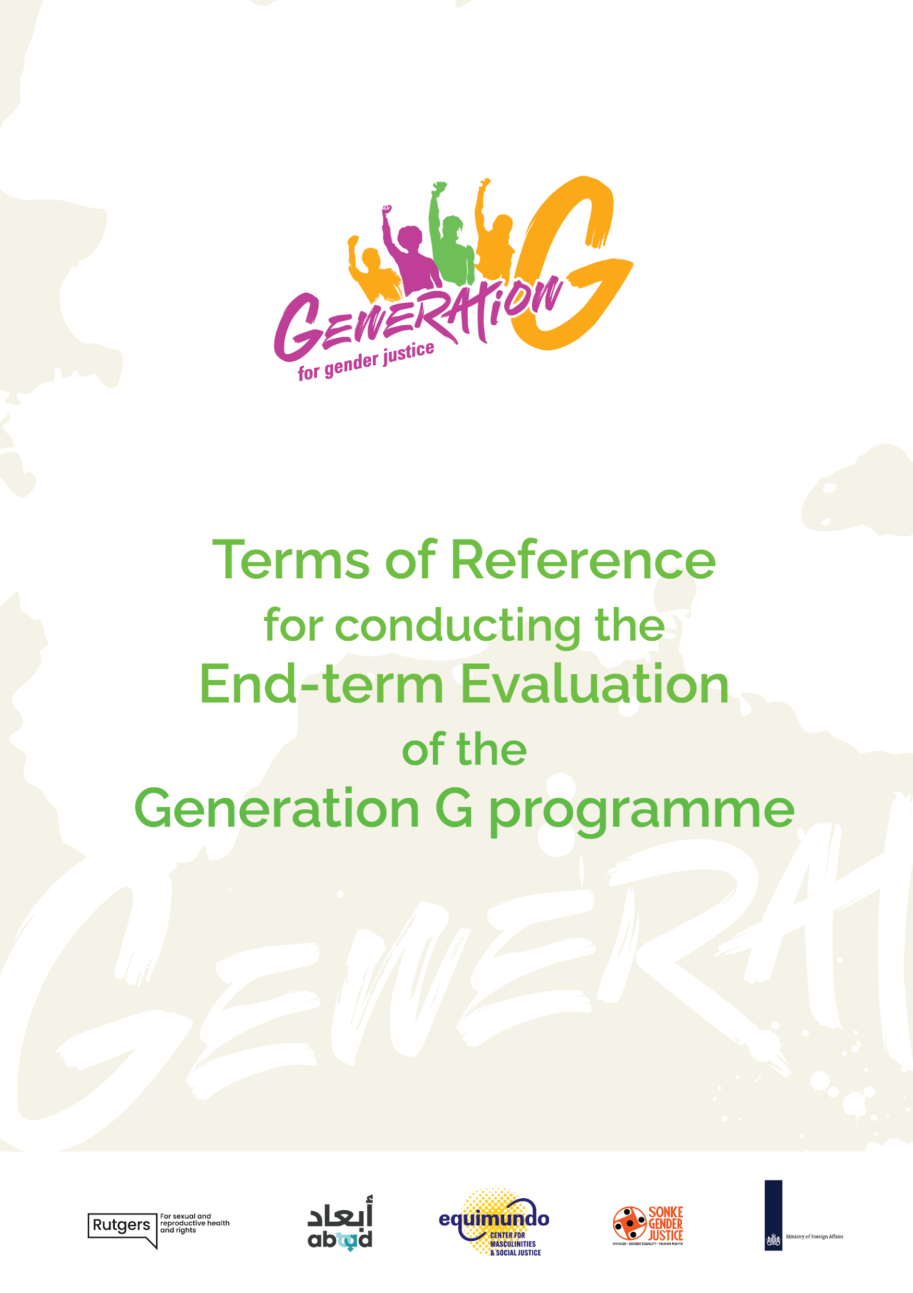

© Generation G Partnership, Utrecht, Netherlands, July, 2024
- Overview

Yayasan Gemilang Sehat Indonesia (YGSI) is looking for a [consultant and youth researcher] for the purpose of conducting an end-term evaluation of Generation G Indonesia according to the terms of reference set out herein.
Key details:
Post title | - National consultant
 | - Youth researcher
Programme Locations: | Indonesia (DKI Jakarta, Bandung, Palu);
Application Deadline: | 15 September 2024
Timeline Contract: | 16 November 2024 – 31 December 2025
Reporting to: | Global end-term evaluation consultant

The Generation G partnership strives towards the creation of gender-just and violence-free societies with and for young people in their full diversity. The partnership raises public support, advocates for improved policies and laws, and strengthens civil society to contribute to achieving gender justice. It thrives on the diversity, strength and collaboration of experts, evidence-based and evaluated approaches, cross-country learning, and global advocacy. Programme activities are running in seven countries in the Global South: Indonesia, Jordan, Lebanon, Morocco, Rwanda, South Africa and Uganda, and will conclude at the end of calendar year 2025. As the end-term date of the programme approaches, the organisations and institutions involved in the programme are eager to investigate the results of their work, and document lessons about the successes and challenges of the programme to inform our future programming and the lobby and advocacy field as a whole, particularly in Indonesia.

- Programme Background

The Generation G partnership raises public support, advocates for improved policies and laws, and strengthens civil society as a means to contribute to gender justice. More specifically, this partnership engages an innovative gender-transformative strategy that equips youth leaders and civil society organisations to address the root causes of gender inequality and power imbalances. Engaging (young) men in promoting gender justice is a key component of this strategy.

The key approach of the programme is a gender-transformative approach. A gender-transformative approach focuses on the following elements: a) investing in amplifying young feminist voices; b) strengthening the role of young men as allies in gender equality; c) promoting human rights and youth agency; d) analysing and addressing harmful norms and unequal power relations; e) embracing sexual and gender diversity.

Next to a gender-transformative approach, this partnership has fully embraced the principles of inclusiveness, meaningful and inclusive youth participation, do no harm and accountability. As young people are our key actors and key impact group, they are actively included in decision-making processes, as well as the design and implementation of key strategies. The diversity in these principles refer to the fact that, although the partnership recognises the need to amplify voices of women and the need to actively engage men, we live in a world where youth have intersecting identities that influence their position in society and access to rights and power. As such, an intersectional feminist approach to gender justice is strongly embedded in the Generation G programme.

Gender-transformative lobbying and advocacy happens at the individual, community, institutional and policy levels. The different levels of gender-transformative lobbying and advocacy are embedded in three mutually reinforcing long-term outcomes (LTOs), described below:
- LTO 1 aims at increasing and mobilising public support for gender justice and rejecting gender-based violence. This LTO also feeds into the other two LTOs as mobilised individuals can become part of organised civil society or might use their voice or voting power to pressure decision makers towards more gender-transformative policies and legislation.
- LTO 2 focuses on strengthening gender-transformative and youth-inclusive policymaking and legislation. This LTO feeds into the other two LTOs as decision makers directly influence the availability of civic space and have a strong influence on the general public through discourse, legislation and policies.
- LTO3 envisions a strong, inclusive and resilient civil society that is able to fight for gender justice. This LTO also feeds into the other two LTOs as a strong civil society is able to advocate for gender-transformative laws and policies and is able to foster and stimulate public support.

Our strategic objective is to create societies that are gender just and violence free, with and for young people in their full diversity. By saying gender just, we imply systemic change at the level of root causes of discrimination, sexism and harmful norms that impede full access to rights for young people on the mere basis of their gender. By violence free, we imply our ambition to actively contribute to a decrease in gender-based violence in the countries where this programme is active.

- Objectives
The end-term evaluation of the Generation G programme has two-fold objectives: programmatic focused and collaboration focused. Detailed objectives are:

- Evaluating the effectiveness of the programme: evaluate the results (including unexpected or unintended results) of the programme, which changes occurred, how changes happened and the contribution of the programme to these changes:

- To assess and validate the country programme progress towards the achievement of the 5-year targets at output and outcome level;
- To assess the country programme strategies regarding:
  - sustainability (what is the likelihood that the programme results will be sustainable, in terms of systems, institutions, policies, financing) and institutionalization (e.g. on GTA and MIYP);
  - operationalisation of programme principles (do we live up to our own principles?);
  - capacity strengthening (Is the programme sufficiently sensitive and responsive to capacity strengthening needs? Is the country's capacity strengthening plan effective and likely to lead to sustained capacity improvements in the long-term?)
- A mapping of funding in relation to budgets vs. expenditures at activity, thematic and geographical level, as well as an evaluation of financial resource management (e.g. appropriateness of budget planning, whether grant allocation has been appropriate, whether there were any bottlenecks in the system of financial disbursement between consortium, national lead partner and coalition partners;
- To assess and analyze towards the baseline result at the beginning of the programme, not limited to how the country addresses the recommendation of the baseline survey.

- Evaluating the partnership collaboration focusing on: coherence, localisation/leading from the South, partnership with the Ministry and the Embassies, lessons learned and good practices.

- Evaluating the relevance and validity of the theory of change: evaluate the programmes’ theory of change including assessing the validity of the assumptions underlying the TOC in the different country contexts by providing evidence of which mechanisms of change worked, which did not, and why.

The Generation G country coalition of Indonesia calls for an external, independent consultant and youth researcher to address these objectives clearly and comprehensively. Further details are presented below.

- Methods and approach
For the Generation G end-term evaluation the realist evaluation approach will be used. See for example: https://www.intrac.org/wpcms/wp-content/uploads/2017/01/Realist-evaluation.pdf. The realist evaluation focuses on understanding what works, for whom and under what circumstances, and will be informed by the programme’s theory of change and context at country and global levels. It is particularly useful for understanding complex interventions and how context influences programmes. A realist evaluation works by going back to the theory of change, mapping how we assume the programme works (i.e. who is doing what and what outcomes do we assume these interventions have), then gathering data to understand if these assumptions are in fact true, and how context has an influence. Data will be collected around these assumptions. A range of data collection methods can be included in a realist evaluation. For this end-term evaluation interviews, focus group discussions, outcome harvesting, and observations will be used, with scope for further methods to be included as needed.

- Scope of Work
The main tasks of the national consultant are as follows:
- Attend an orientation meeting with global consultants and the Generation-G team;
- Attend an end-term evaluation planning meeting in Rabat Morocco, which will be held from 2 – 6 December 2024. Participation is mandatory, you must be available for this week, and eligible to fly to Morocco. All costs such as flight and hotel will be reimbursed by the lead agent Rutgers. Per diems and visa costs will be paid by the global consultant;
- Attend training on a) the Realist Evaluation approach (most likely this will integrated into the planning meeting week in Morocco), and b) data collection, including pre-testing the tools;
- Translate and contextualize the tools;
- Lead on all logistical planning and arrangements of the data collection activities;
- Facilitate focus group discussions (FGDs), key informant interviews (KIIs) and conduct observations at country level;
- Review country project reports and validate progress against indicators targets and key learning identified at country level;
- Support data analysis lead by the global consultant;
- Develop a field work report, including country specific recommendations;
- Provide input for the preliminary findings;
- Provide input for the final report.

Expected Deliverables
- Recording of each interview and FGD session conducted;
- Summarised transcripts of interviews and FGD sessions in English;
- Field notes of how the field work was implemented (including supporting and hindering factors during the field work, observation notes);
- Part of the draft report related to the assigned work – will be discussed further during the data collection;
- Other deliverables that are needed by the global consultants – will be discussed further during the online training.

Duration:
Approximately 45 days (spread between November 2024 - September 2025).

Travel:
The consultant will work in the home country, with travel to the sites. YGSI will cover the in-country travel expenses, including accommodation and per diem. Attendance at the end-term evaluation planning meeting in Rabat Morocco, 2 – 6 December 2024 is mandatory. All costs for this meeting such as flight and hotel will be reimbursed by the lead agent Rutgers. Per diems for this meeting will be paid by the global consultant.

Qualifications and specialized knowledge, experience and skills required:
- Master degree in a relevant subject e.g. development studies, social studies, public health;
- Proven track record in the evaluation of complex programs, with specific attention to gender equality and gender justice especially in the area of SGBV, advocacy, campaign, and civil society strengthening;
- A solid understanding of the social, political, and cultural context in Indonesia;
- At least 10 years of relevant working experience with civil society organisation or research institute, and experience working with vulnerable communities, including youth, women and girls;
- Proven track record in facilitating participatory evaluation workshop and qualitative data collection;
- Preferable experienced in the Realist Evaluation Approach;
- Understanding Gender Transformative Approach (GTA) and Meaningful and Inclusive Youth Participation (MIYP);
- Knowledge of human rights, gender justice, gender transformative lobbying and advocacy, intersectionality, youth agency, youth inclusive policy making and legislation and collaborative programming, including approaches to engage men and boys;
- Written and spoken fluency in English and Bahasa Indonesia. Understanding and can communicate with local language used in Bandung, West Java and dialect in Palu, South Sulawesi is an advantage;
- Familiarity with the Most Significant Change (MSC) and Outcome Harvesting is an advantage;
- Ability to travel in-country.

Conflict of Interest (CoI):
National consultants should not have COI nor have been involved in the Generation G programme nor have been working/worked with one of organisations implementing the Generation G programme.

The main tasks of the youth researcher are as follows:
- Attend an orientation meeting with the global consultant and Generation-G team;
- Attend an end-term evaluation planning meeting in Rabat Morocco, which will be held from 2 – 6 December 2024. Participation is mandatory, you must be available for this week, and eligible to fly to Morocco. All costs such as flight and hotel will be reimbursed by the lead agent Rutgers. Per diems and visa costs will be paid by the global consultant;
- Attend training on a) the Realist Evaluation approach (most likely this will integrated into the planning meeting week in Morocco), and b) data collection, including pre-testing the tools;
- Assist the national consultant with logistical planning and arrangements of the data collection activities;
- (Co)facilitate focus group discussions, key informant interviews and story of changes interviews at country level;
- Check the quality of the transcriptions of interviews and discussions.
- Provide input for the preliminary findings;
- Provide input for the final report.

Expected Deliverables (jointly with the national consultant)
- Recording of each interview and FGD session conducted;
- Summarised transcripts of interviews and FGD sessions in English;
- Field notes of how the field work was implemented (including supporting and hindering factors during the field work, observation notes);
- Part of the draft report related to the assigned work – will be discussed further during the data collection;
- Other deliverables that are needed by the global consultants – will be discussed further during the online training.

Duration:
Approximately 30 days (spread between November 2024 - September 2025)

Travel:
The youth researcher will work in their home country, with travel to the sites. YGSI will cover the in-country travel expenses, including accommodation and per diem. Attendance at the end-term evaluation planning meeting in Rabat Morocco, 2 – 6 December 2024 is mandatory. All costs for this meeting such as flight and hotel will be reimbursed by the lead agent Rutgers. Per diems for this meeting will be paid by the global consultant.
Qualifications and specialized knowledge, experience and skills required
- University degree in a relevant subject e.g. development studies, social studies, public health;
- Between 15 and 32 years of age;
- Experience in the area of SGBV, advocacy, campaign and civil society strengthening;
- A solid understanding of the social, political, and cultural context in Indonesia;
- Experience working with vulnerable communities, including youth, women and girls;
- At least 5 years of experience in conducting qualitative research, including key informant interviews and focus group discussions;
- Written and spoken fluency in English and Bahasa Indonesia. Understanding and can communicate with local language used in Bandung, West Java and dialect in Palu, South Sulawesi is an advantage.

Conflict of Interest (CoI):
Youth researchers should not have COI nor have been involved in the Generation G programme nor have been working/worked with one of organisations implementing the Generation G programme.

Remarks:
  - Only shortlisted candidates will be contacted and advance to the next stage of the selection process.
  - Monitoring deliverables about work progress are not listed but will be periodically required.

- How to Apply

Applications for this role are open until 15 September 2024. Please send your application through email to: recruitment@gemilangsehat.org with the subject “ETE National Consultant and Youth Researcher Gen G”.
Please limit the expression of interest to no more than 10 pages. The expression of interest text should be a narrative demonstrating the following:
- Your skills and background that make you suitable for this assignment;
- Your track record on the evaluation of advocacy programmes, gender justice, meaningful and inclusive youth participation, gender-transformative lobbying and advocacy, youth-inclusive policy making and legislation; send two examples of recent evaluations with your application;
- Budget plan, including consultancy fee.

In addition to the proposal text, please submit supplementary materials including the following:
- CVs, highlighting relevant experience and personal profile.
- At least one, preferably two recent studies/writing examples on similar themes with significant/primary writing by the lead researcher.
Annex I: Theory of Change of Generation G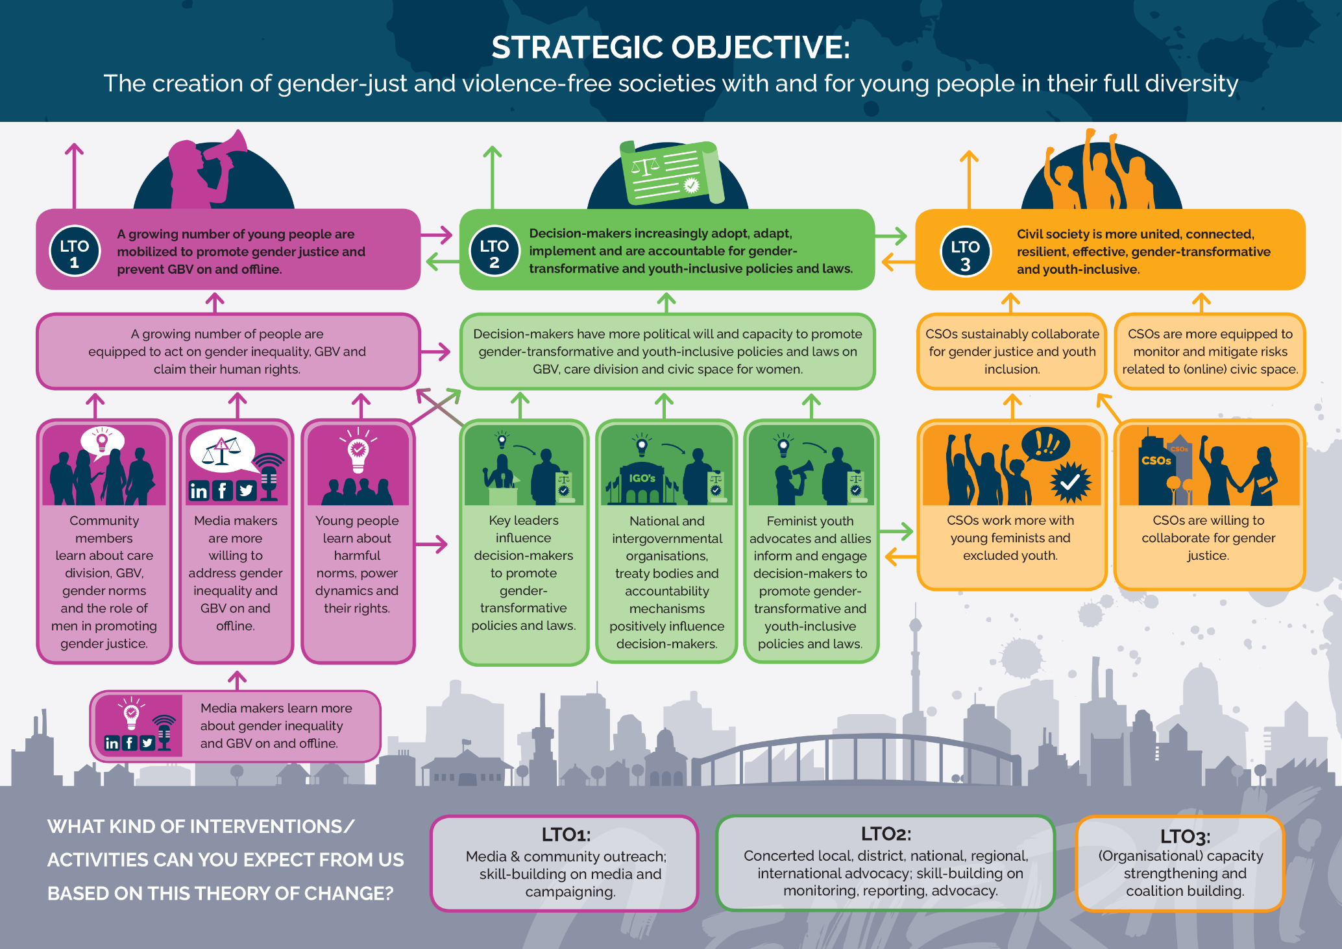
Annex 2: Detailed outline and assumptions per long-term outcome (LTO)

LTO 1: A growing number of young men and women are mobilised to promote gender justice and prevent GBV on and offline

LTO 1 assumptions:
- Awareness and knowledge about harmful norms and power dynamics lead to action against gender inequality and GBV.
- When young people, communities and media act simultaneously, it enhances the promotion of gender justice and the prevention of GBV (on and offline).

To achieve this long-term outcome, we identified one key precondition: people are aware of harmful norms and power dynamics and equipped to act on gender inequality and GBV. This is advanced by the following pathways of change:
- Communities participate in dialogues and programmes on GBV, gender norms and men’s role in promoting gender justice on and offline. Since community programmes need to be organised, fostered and fed, CSOs need to have the capacity to stimulate these processes.
- CSOs are able to directly campaign towards the public.
- Media makers (traditional and new) effectively address gender justice and GBV on and offline.
- Since media makers need to be informed and committed, CSOs need to be able to reach out, offer support and provide correct information.

Key interventions include:
- Media and community outreach and mobilisation on care division, GBV, and civic space for women through community-based dialogues and programming, on and offline outreach activities, working with media on gender-transformative messaging, nudging and influencing.
- Skill-building for CSOs and media makers on media and gender-transformative campaigning through training and mutual learning.

LTO 2: Decision-makers increasingly adopt, adapt, implement and are accountable for gender-transformative and youth-inclusive policies and laws

LTO 2 assumptions:
- Lobbying and advocacy are most effective when happening at multiple levels simultaneously
- Policies and laws are more likely to become youth-inclusive if youth are meaningfully included in these processes.

We will focus on decision-makers at the local, district and national level within their countries. Implementation includes budgeting and staffing. In order to achieve LTO2, we have identified one key precondition: decision-makers have political will and capacity to promote gender-transformative policies and laws related to GBV, care division and civic space for women.

This is advanced by four pathways of change:
- Key leaders influence decision-makers to promote gender-transformative laws and policies. For us, key leaders are people with influence and audience, including religious leaders, social media influencers, celebrities, political leaders, civil society leaders and business leaders. In order for key leaders to wield their influence, civil society movements need the capacity to effectively engage them.
- CSOs directly advocate towards decision-makers.
- National and intergovernmental organisations, treaty bodies and accountability mechanisms (e.g. national human rights institutions, Ombuds organisations, UN agencies, the African Union, CEDAW and UPR) positively influence decision-makers. To effectively use these spaces, CSOs need capacity to exercise influence in them.
- Feminist youth advocates and allies inform and engage decision-makers to promote gender-transformative and youth-inclusive policies and laws. Civil society needs to be able to support and facilitate these advocates in this process, for example through training, brokering, mentoring and joint advocacy.
- By capacity we mean awareness, knowledge, skills, understanding, space, financial resources and connections.

Key interventions include:
- Concerted advocacy at the local, district, national, regional, international level that is youth-inclusive and gender-transformative. This requires simultaneous campaigns, technical assistance for governments, and facilitating access to political spaces for youth advocates.
- Skill-building for CSOs and key leaders on policy and law monitoring, reporting and gender-transformative lobbying and advocacy.

LTO 3: Civil society for gender justice is increasingly resilient, effective, gender-transformative and youth-inclusive

LTO 3 assumptions:
- Civil society is more efficient if it is strong, unified and inclusive.
- Civic space can be safeguarded and expanded if resilient and diverse civil society actors work

LTO3 directly contributes to the preservation and, where possible, expansion of civic space. This LTO is advanced by two pathways of change:
- CSOs jointly embrace gender-transformative approaches and youth participation. To do so, CSOs need to be willing and able to collaborate for gender justice. Moreover, young feminists and excluded groups need to be able to voice their needs.
- CSOs are able to monitor and mitigate risks related to backlash, harassment, conflict and opposition in on and offline civic space. This precondition feeds directly into the resilience of civil society. Therefore, civil society needs to have the capacity to assess what kinds of risks exist and which risk-mitigation measures are appropriate.

Key interventions include:
- Tailor-made organisational capacity strengthening focused on, for example, financial resilience(including post-programme resilience) and management, leadership and planning, monitoring, evaluation and learning (PMEL).
- Coalition-building through joint programme design, value clarification, and brokering connections.
- Skill-building on holistic safety and security, including monitoring opposition and attacks on gender.
- Capacity strengthening on human rights, youth inclusion and GTA.

